Software Requirements Specification

for

Clinic Management System

**Version 1.0 approved**

**Prepared by Pham Vinh Nhan, Cao Chi Hai, Truong Binh Tan, Nguyen Thai Thinh**

**Group 1**

**September 8, 2021**

**Table of Contents**

**Revision History ii**

**1.** **Introduction 1**

1.1 Purpose 1

1.2 Document Conventions 1

1.3 Project Scope and Product Features 1

1.4 References 1

**2.** **Overall Description 1**

2.1 Product Perspective 1

2.2 User Classes and Characteristics 2

2.3 Operating Environment 3

2.4 Design and Implementation Constraints 3

2.5 Assumptions and Dependencies 3

**3.** **System Features 3**

3.1: Make appointment online 3

3.1.1: Description 3

3.1.2: Functional Requirements 3

3.2: Create, view, update patient’s record 4

3.2.1: Description 4

3.2.2: Functional Requirements 5

3.3: Order medicine online 5

3.2.1: Description 5

3.2.2: Functional Requirements 5

**4.** **Data Requirements 6**

4.1 Logical Data Model 6

4.2 Data Dictionary 6

4.3 Reports 9

4.3.1 Appointment History Report 9

4.3.2 Order History Report 9

4.4 Data Integrity, Retention, and Disposal 9

**5.** **External Interface Requirements 11**

5.1 User Interfaces 11

5.2 Software Interfaces 19

5.3 Hardware Interfaces 19

5.4 Communications Interfaces 19

**6.** **Quality Attributes 19**

6.1 Usability Requirements 19

6.2 Performance Requirements 19

6.3 Security Requirements 20

6.4 Safety Requirements 20

6.5 Availability Requirements 20

6.6 Robustness Requirements 20

**Appendix A: Analysis Models 21**

**Appendix B: DFD 22**

**Appendix C: Swimlane Diagram 23**

**Appendix D: Class Diagram 24**

**Revision History**

| **Name** | **Date** | **Reason For Changes** | **Version** |
| --- | --- | --- | --- |
| Assignment 1 | 15/10/2021 | First init | 1.0 |
| Assignment 2 | 36/10/2021 | Update | 2.0 |

# Introduction

## Purpose

This SRS describes the functional and nonfunctional requirements for software release 1.0 of the Clinic Management System (CSM). This document is intended to be used by the members of the project team who will implement and verify the correct functioning of the system. Unless otherwise noted, all requirements specified here are committed for release 1.0.

## Document Conventions

No special typographical conventions are used in this SRS.

## Project Scope and Product Features

The CSM will permit Process Impact doctors and nurses to create, update and add records about patients, and the patients can take an appointment. A detailed description is available in the *Clinic Management System Vision and Scope Document* [1], along with the features that are scheduled for full or partial implementation in this release.

## References

# Overall Description

## Product Perspective

The Clinic System is a new website that provides service for both employees and customers. The new website includes an online management system for doctors and nurses, which allows them to control the schedule, modify all the clinic information, etc. Moreover, the system also has an online website for patients, which provides them online taking appointments, selecting the time, and updating their information. The context diagram in Figure 1 illustrates the external and system interface for release 1.0. The system is expected to evolve over several releases.

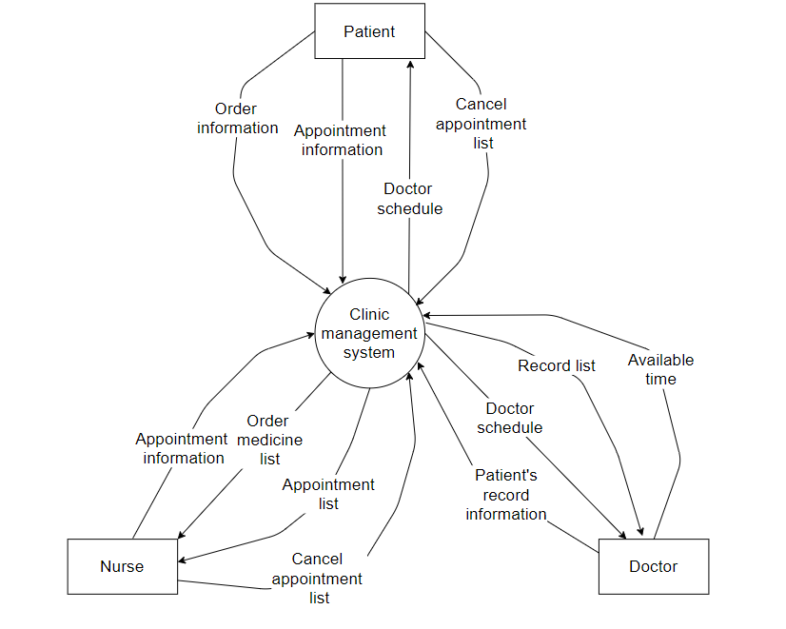

**Figure 1. Context diagram for release 1.0 of the Clinic Management System.**

## User Classes and Characteristics

| Doctor | Doctors should fairly know about the usage of the system.Doctors are able to see the respective appointments taken. And also can view patient’s details and records. |
| --- | --- |
| Nurse | Nurses will receive medicine orders and appointments from the CMS to manage clinic schedules and orders flow. |
| Patient | Patients can view their own information, records and doctors details, schedules. Also can make appointment online |
|  |  |

## Operating Environment

OE-1: The CMS shall operate correctly with the following web browsers: Windows Internet Explorer versions 7, 8, and 9; Firefox versions 12 through 26; Google Chrome (all versions); and Apple Safari versions 4.0 through 8.0.

OE-2: The CMS mobile app shall run on the android operating system version 5.0 through 11 .

OE-3: The CMS mobile app shall run on the IOS operating system version 8.0 through 15

## Design and Implementation Constraints

CO-1: The CMS shall be a web based application system running in a web browser environment and mobile app on android and IOS.

CO-2: The system shall use the current corporate standard SQL Server and ASP.NET.

CO-3: All HTML code shall conform to the HTML 5.0 standard.

## Assumptions and Dependencies

AS-1: The CMS must have an interface which is simple enough to understand, and fast response time.

AS-2: The CMS must have a friendly-interface which is simple to use.

DE-1: The operation of the CMS depends on changes being made in the nurse to accept payment requests for medicine ordered with the CSM .

# System Features

## Make appointment online

### Description

Patient access the CMS through the internet, views the doctor available for appointment, selects doctor, and chooses time for an appointment

### Functional Requirements

| **Appointment.Make: Making an appointment**  .Select: The CMS shall display all available doctors for a specific date. Patients choose a specific time and doctor to make an appointment. The patient can also make multiple appointments as it’s not the same time. If there is no doctor left, the CMS will inform the patient and send message when doctor available  .Make: Patients can either confirm the appointment or return to modify the appointment. If the patient confirms the appointment the CMS will send a message confirming appointment details and instructions to the patients. CMS stores appointment records in database and update doctor’s schedule that assigned to the appointment |
| --- |
| **Appointment.Cancel: Cancel an appointment**  .Select: Patient will choose a specific appointment they want and confirm to cancel  .Cancel: Patient can cancel any appointment if thẻre are till one day before the appointment date. after patient cancel, CMS will display a success message and update the doctor’s schedule |
| **Appointment.View: Viewing a appointment**  .Detail: The doctor and nurse can view the appointment details on a specific date.  .Times: The CMS shall display the remaining available times for the appointment date. |

## Create, view, update patient’s record

### 3.2.1 Description

Doctor access to the clinic system via the internet, can create new, update and view patient’s record

### 3.2.2 Functional Requirements

| **Record.Create: Create a record**  .Input: The CMS shall display a record form for the doctor to fill in the information.  .Create: The CMS will validate the input from the doctor, if the input wrong pattern or the patient may already exist in the database, the system will request the doctor fill in the form again, if the input is valid, display the success message.  .Cancel: Doctor can cancel the create operation. |
| --- |
| **Record.Update: Update a record**  .Input: The CMS shall display a record form for the doctor to fill in the record information they want to update  .Update: The CMS will validate the input from the doctor, if the input is wrong or the patient does not exist, the system will request the doctor fill in the form again or doctor can create a new record, if the input is valid, update the database and display the success message.  .Cancel: Doctor can cancel the update operation. |
| **Record.View: View a record**  .Input: The doctor can view the patient’s record details if they input valid record information to search.  .Detail: The CMS shall display all the details about the record. |

## Order medicine online

### 

| **Order.Create: Create an order**  .Input: The patient will fill the doctor’s prescription form and search in the database if the description exists or not.  .Order: The patient input the quantity they want and make an order.  .Available: CMS checks the quantity in the medicine stock store in the database if the quantity is enough or not. if not the CMS send patient a message when the medicine is available |
| --- |

# Data Requirements

## Logical Data Model

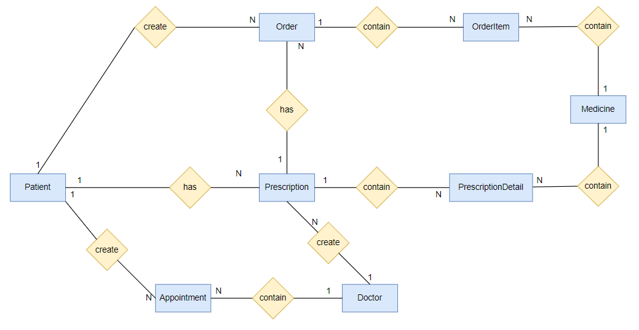

**Figure . Partial data model for release 1.0 of the Cafeteria Ordering System.**

## Data Dictionary

| **Data Element** | **Description** | **Composition or Data Type** | **Length** | **Values** |
| --- | --- | --- | --- | --- |
| Patient |  |  |  |  |
| patient ID | ID of a patient who is took of by nurse in CMS | string | 16 | random |
| patient name | full name of a patient | string | 5-50 | Must be real name |
| patient age | age of a patient | int | 1-120 | Must be real age |
| patient email | email of a patient | string | 1-255 | Must be valid email |
| patient address | address of a patient | string | 1-255 | Must be real address |
| patient phone | phone number of patient | string | 10-25 | Must be patient’s personal phone number |
| Nurse |  |  |  |  |
| nurse ID | ID of a nurse | string | 16 | random |
| nurse name | full name of a nurse | string | 5-50 | Must be real name |
| nurse age | age of a nurse | int | 1-120 | Must be real age |
| nurse email | email of a nurse | string | 1-255 | Must be email provided by administrator |
| patient nurse | address of a nurse | string | 1-255 | Must be real address |
| nurse phone | phone number of nurse | string | 10-25 | Must be patient’s personal phone number |
| Doctor |  |  |  |  |
| doctor ID | ID of a doctor | string | 16 | random |
| doctor name | full name of a doctor | string | 5-50 | Must be real name |
| doctor age | age of a doctor | int | 1-120 | Must be real age |
| doctor email | email of a doctor | string | 1-255 | Must be email provided by administrator |
| doctor salary | salary of a doctor | double |  | Must be VNĐ |
| doctor phone | phone number of doctor | string | 10-25 | Must be patient’s personal phone number |
| Medicine |  |  |  |  |
| medicine ID | ID of a medicine | string | 16 | random |
| medicine name | full name of a medicine | string | 5-50 | Must be full name |
| medicine price | price of a medicine | int | 1-10000 | x(1000VND) |
| medicine manufacturer | name of the manufacture | string | 5-50 |  |
| Prescription |  |  |  |  |
| prescription ID | ID of a prescription | string | 16 | random |
| doctor ID | ID of a doctor who create this prescription | string | 16 |  |
| patient ID | ID of a patient who take this prescription from the doctor | string | 16 |  |
| create date | the date that doctor create this list | date, MM/DD/YYYY | 10 |  |
| Prescription Detail |  |  |  |  |
| prescription ID | ID of the prescription contain this detail | string | 16 |  |
| medicine ID | ID of medicine | string | 16 |  |
| dosage | the size or frequency of a dose of a medicine or drug | string |  |  |
| quantity | number of medicine that doctor listed | int |  |  |
| Appointment |  |  |  |  |
| appointment ID | ID of a appointment | string | 16 | random |
| doctor ID | ID of a doctor that patient booked him | string |  |  |
| patient ID | ID of a patient who create create this appointment | string |  |  |
| appointment date | the date that the appointment will occur | date, MM/DD/YYYY | 10 |  |
| appointment time | the time that the appointment will occur | time, HH/MM | 5 |  |
| Order |  |  |  |  |
| order ID | ID of a order | string | 16 | random |
| order total price | total price of all medicine that order contains | int | 1-10000 | x(1000VND) |
| order date | the date that the order will be create by patient | date, MM/DD/YYYY | 10 |  |
| patient ID | ID of a patient who create create this order | string |  |  |
| create date | the date that patient create this order | date, MM/DD/YYYY | 10 |  |
| order payment | name of payment method | string | 5-50 | card, cash, online payment |
| Order Item |  |  |  |  |
| order item ID | ID of a item order | string | 16 | random |
| medicine ID | ID of medicine that patient want to buy | string | 16 |  |
| quantity | number of medicine that patient want to buy | int | 1-1000 |  |

## Report

4.3.1 Make appointment online report:

| Report ID: | COS-RPT-1 |
| --- | --- |
| Report Title: | Appointment History |
| Report Purpose: | The patient wants to see a list of all appointments that he booked from the doctor with a specified time, so he can view or cancel a particular appointment he wants.. |
| Priority: | Medium |
| Report Users: | Patients |
| Data Sources: | Database of previously placed appointments |
| Frequency and Disposition; | Report is generated on demand by a Patient. Data in the report is static. Report is displayed on the user's web browser screen on a computer, tablet, or smartphone. It can be printed if the display device permits printing. |
| Latency: | Complete report must be displayed to Patient within 3 seconds after it is requested. |
| Visual Layout: | Landscape mode |
| Header and Footer: | Report header shall contain the report title,Patient's name, Doctor’s name, and date booking appointment, medical examination description and date range specified. If printed, the report footer shall show the page number. |
| Report Body: | Fields shown and column headings:  · Appointment ID  · Appointment Date  . Patient’s information  . Doctor’s information  · Illness information    Selection Criteria: date range specified byAppointment Date  Sort Criteria: Appointment Date |
| End-of-Report Indicator: | None |
| Interactivity: | Patients can drill down to see Doctor’s information. |
| Security Access Restrictions: | A Patient may retrieve only his own appointment history |

4.3.1 Make appointment online report:

| Report ID: | COS-RPT-2 |
| --- | --- |
| Report Title: | Ordered Medicine History |
| Report Purpose: | Patient wants to see a list of all prescriptions that he had previously ordered from the CMS, so he can reorder a particular prescription he likes. |
| Priority: | Medium |
| Report Users: | Patient |
| Data Sources: | Database of previously placed meal orders |
| Frequency and Disposition; | Report is generated on demand by a Patient. Data in the report is static. Report is displayed on the user's web browser screen on a computer, tablet, or smartphone. It can be printed if the display device permits printing. |
| Latency: | Complete report must be displayed to Patient within 3 seconds after it is requested. |
| Visual Layout: | Landscape mode |
| Header and Footer: | Report header shall contain the report title, Patient's name, and date range specified. If printed, the report footer shall show the page number. |
| Report Body: | Fields shown and column headings:  · Order ID  · Order Date  · Payment method  · Items ordered (list all items in the medicine order, their quantity, and their prices)  · Tax  · Delivery Charge  · Total Price (sum of medicine item prices, tax, and delivery charge)    Selection Criteria: date range specified by Patient, inclusive of end points  Sort Criteria: reverse chronological order |
| End-of-Report Indicator: | None |
| Interactivity: | Patron can drill down to see ingredients and nutritional information for each item in the order |
| Security Access Restrictions: | A Patient may retrieve only his own medicine order history |

## Data Integrity, Retention, and Disposal

DI-1: The CMS shall access Patient record orders for 12 months before the last appointment.

DI-2: The CMS shall access the medicine bill for one year following the creation date.

DI-3: The CMS shall retain user data when their not active in 10 year

DI-4: The CMS allow user to search medicine bill within 6 month

# External Interface Requirements

## User Interfaces

UI-1: The Clinic Management System screen displays shall conform to the *Process Impact Internet Application User Interface Standard, Version 2.0* [3].

UI-2: The system shall provide a help link from each displayed web page to explain how to interact with that page.

UI-3: The webpages shall permit complete navigation to any page using the keyboard alone, in addition to using mouse and keyboard combinations.

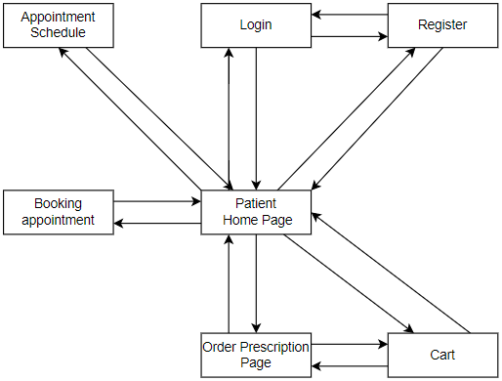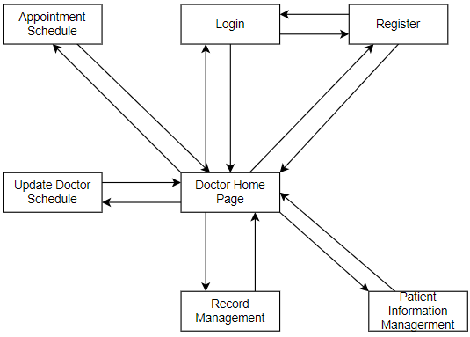

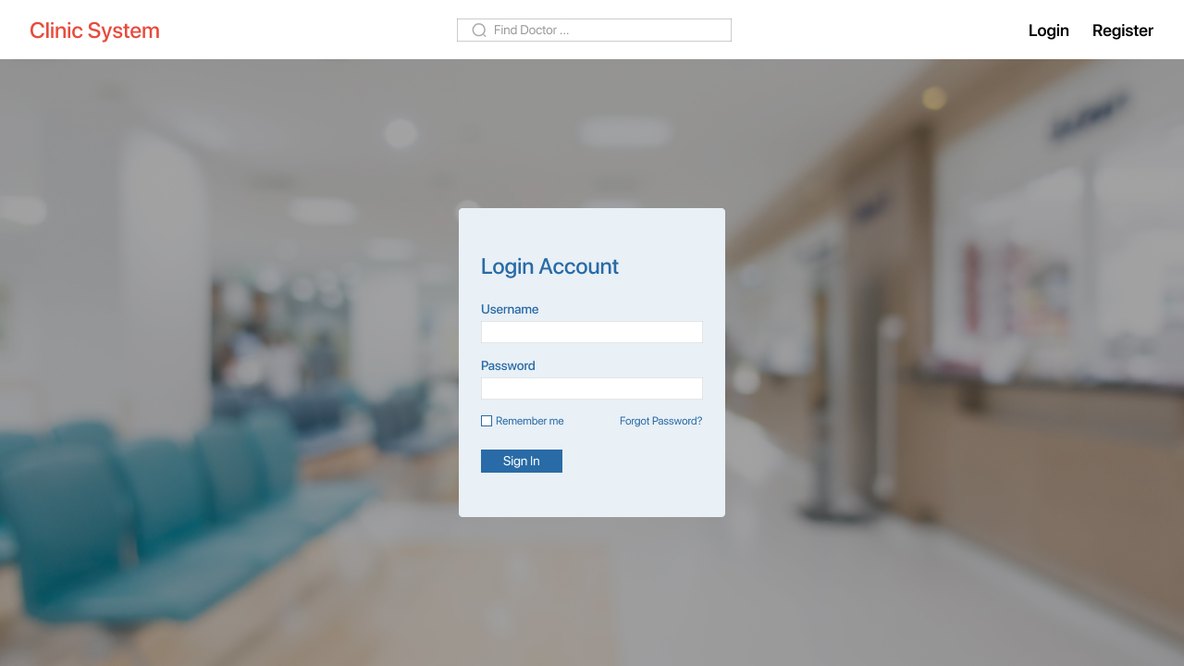

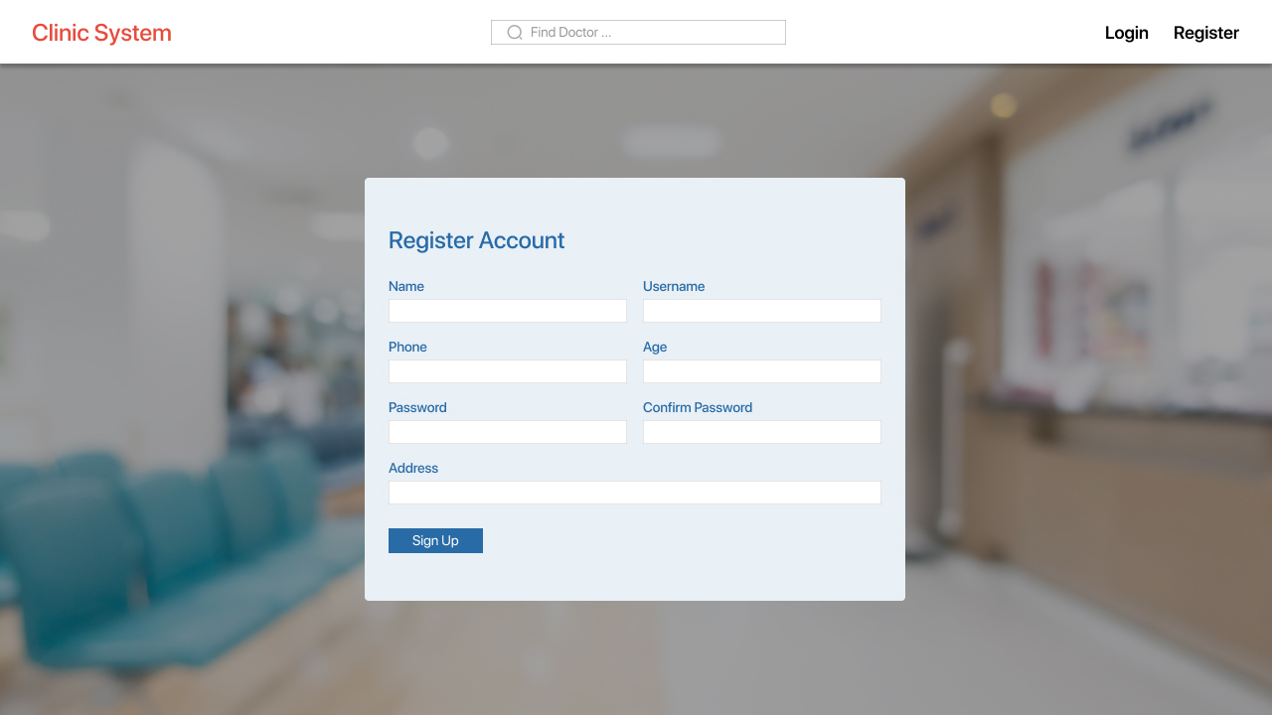

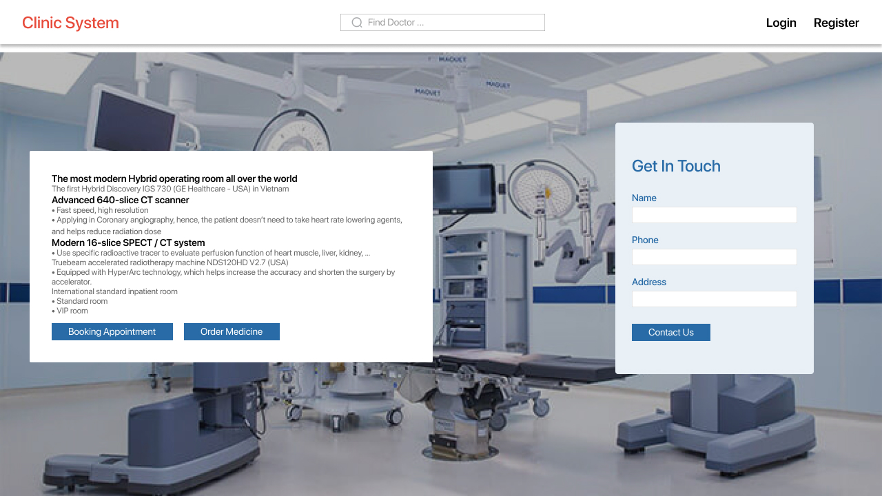

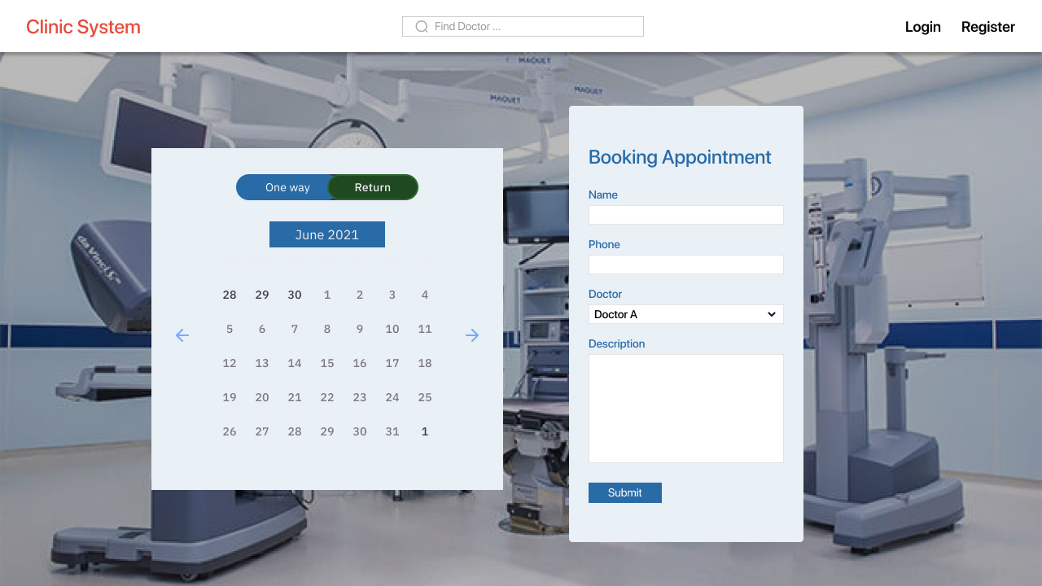

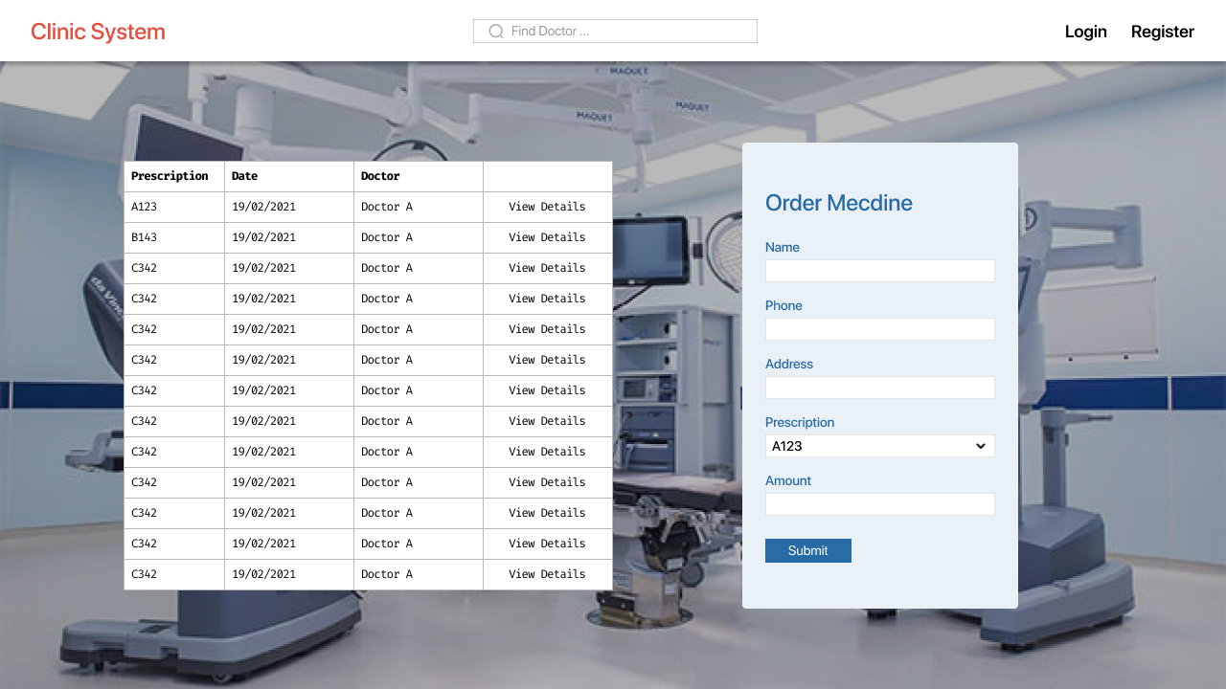

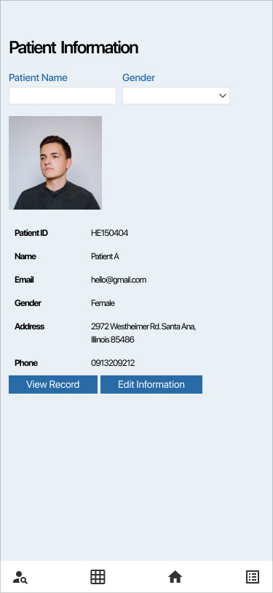

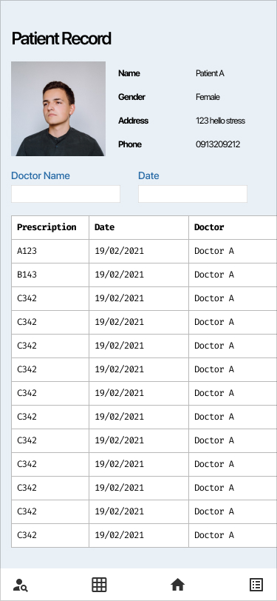

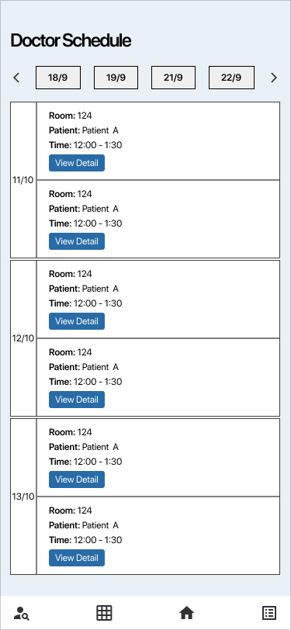

## Software Interfaces

SI-1: Order Medicine System

SI-1.1: The CMS shall transmit the quantities of Medicine items ordered to the Clinic Inventory System through a programmatic interface.

SI-1.2: The CMS shall poll the Clinic Inventory System to determine whether a requested medicine item is available.

SI-1.3: When the Clinic Inventory System notifies the CMS that a specific medicine item is no longer available, the CMS shall send a message to the patient when it is available.

SI-2: Appointment System

SI-2.1: To allow a Patient to make and cancel an appointment.

SI-2.2: To inquire whether a Doctor is registered for any appointment.

SI-2.3: To inquire whether a Patient is making any appointment.

SI-2.4: To submit an appointment request for a specific date.

## Hardware Interfaces

No hardware interfaces have been identified.

## Communications Interfaces

CI-1: The CMS shall send an email or text message (based on user account settings) to the patient to confirm the appointment.

CI-2: The CMS shall send an email or text message (based on user account settings) to the patient when the appointment is canceled or changed to another time.

# Quality Attributes

## Usability Requirements

USE-1: The CMS shall allow a patient to retrieve the previous treatment and order online medicine via the previous record.

USE-2: 97% of new users shall successfully book an appointment without errors on their first try.

## Performance Requirements

PER-1: The system shall accommodate a total of 200 users and a maximum of 30 concurrent users during the opening time window of 6:45 A.M. to 10:00 A.M. local time, with an estimated average session duration of 20 minutes.

PER-2: 95% of web pages generated by the CSM shall download entirely within 3 seconds from when the user requests the page over a 30Mbps or faster Internet connection.

PER-3: The system shall display confirmation messages to users within an average of 2 seconds and a maximum of 4 seconds after the user submits information to the system.

## Security Requirements

SEC-1: All network transactions that involve financial information or personally identifiable information shall be encrypted per Bcrypt.

SEC-2: Users shall be required to log on to the CMS for all operations except viewing a doctor's schedule for taking appointments.

SEC-3: Only authorized nurses shall be permitted to add, update, and modify the information of patients.

SEC-4: The system shall permit nurses to view all the doctor schedules, and allow them to assign doctors to particular appointments.

## Safety Requirements

SAF-1: The system will highlight all ingredients for the doctor before selecting, that are known to cause allergic reactions in more than 5% of the Vietnamese population.

## Availability Requirements

AVL-1: The CMS shall be available at least 98% of the time between 6:45 A.M. and midnight local time and at least 90% of the time between midnight and 5:00 A.M. local time, excluding scheduled maintenance windows.

## Robustness Requirements

ROB-1: If the connection between the doctor or nurse and the CMS is broken prior to a new record being either confirmed or terminated, the CMS shall enable the user to recover an incomplete record and continue working on it.

# Appendix A: Analysis Models

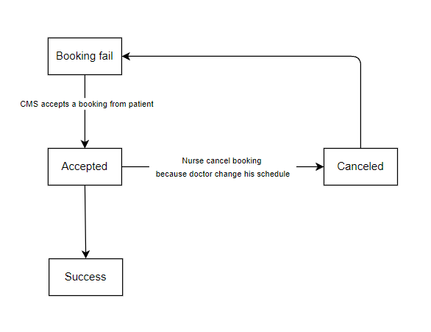

# Appendix B: DFD

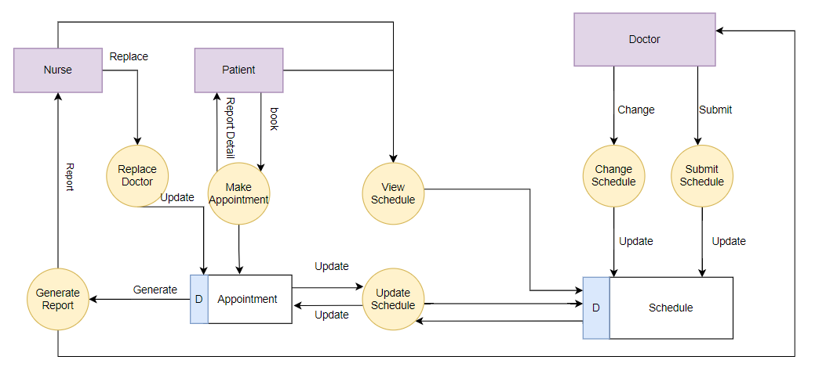

# Appendix C: Swimlane Diagram

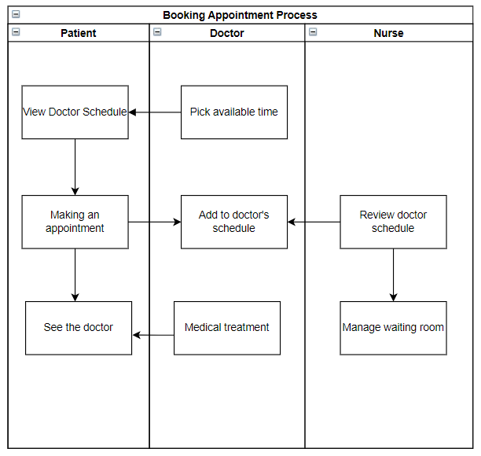

# Appendix D: Class Diagram

